www.ArcaneMagicSpellBook.com

Make A Genie In Command(MAGIC) Genies In Zones; Magical Ordering System(GIZMOS)

The Supreme Magic Kit: www.magicgizmos.com
By:
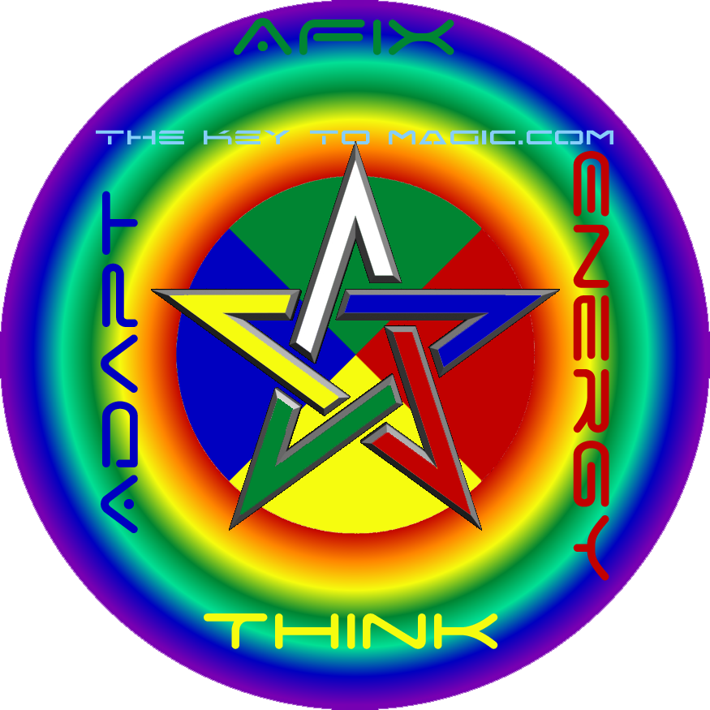
Spirit = consciousness directing something. Composition that is both ruled by and ruling over the 4 elements.
Fire = energy in the form of light of all velocities. Phons exist at infinity(aware of Itself as everything) or 0(aware of Everything as itself) frequency traveling at 0 or infinite velocity. Light that composes all things as phonon(slow light) clusters in quantum particles. Active and Mutable. Plasma. Had. Red and Green.
Air = abstraction. Thinking. Quantum Law, Relativity, And Laws And Rules In General. Active and Fixed. Gas. Hadit. Yellow and Purple. To see Fairies look for the angel wings when you see diffraction from a thin slit that you are staring through to see the light source. But Fairies are just mostly air driven unlike Sylphs.
Water = adaptation. Change In General. Effect of Forces both external and hidden and Quantum Jumping. Passive and Mutable. Liquid. Nu. Blue and Orange.
Earth = affix. Definition of the Universe across all space time from the beginning of time(Big Bang) to the end of time(Everything In Zero Point All Light Nirvana) by previous elements.. Passive and Fixed. Solid. Nuit. Black and White.
Energy Abstracted in an Adapting Environment Defines spacetime.

The Spirits of Fire or Salamanders are in all ons(particles) which have light memory of anything and some of everything. The Spirits of Air or Sylphs are in all ons for the ability to reabstract the properties of Spacetime which defines quantum law. The Spirits of Water or Undines are in all ons for the ability to Cause adaptive changes in the universe. The Spirits of Earth or Gnomes are in all ons for through our infinite Spirit memory. Capability to reabstract the universe, and ability to adapt causes us to define Spacetime as our present becomes etched into the fixed slate of the past.
All intraelemental colors are flashing colors because they stand out the most due to the way our eyes perceive light.

Spirit = top of pentagram. To invoke draw from Earth. To banish draw to Earth.
Fire = bottom right of pentagram. To invoke draw from spirit. To banish draw to spirit.
Air = middle left of pentagram. To invoke draw from Fire. To banish draw to Fire.
Water = middle right of pentagram. To invoke draw from Air. To banish draw to Air.
Earth = bottom left of pentagram. To invoke draw from Water. To banish draw to Water.
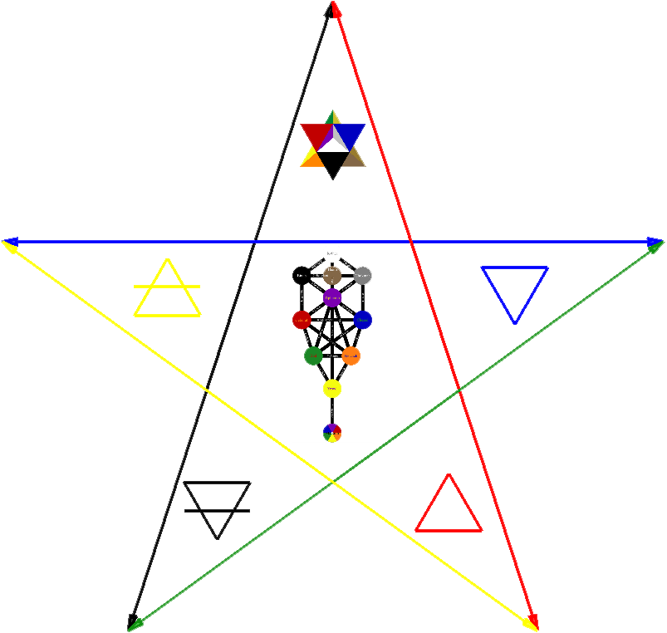
In short invocations generally come from lighter elements to heavier elements, banishings from heavier to lighter. Invocation is clockwise, banishing counterclockwise. Both invocation and banishing start from 1 point and return to that point after passing through the pentagram. Movement of your body around the alter should always be clockwise. The entire proceeding must occur in a closed space or within a drawn circle.

The reason why the directions of Fire and Air have been swapped relative to conventional thought is because magical invocation should follow the path of the pentagram and has nothing to do with the direction people at a northerly latitude would go to be in a warmer climate. What if you live in Australia; do you make Fire North and Earth South. It does however have to do with Earth's magnetic field as the electromagnetic force field of the universe is in essence the Kerubim. Wands should have an iron(or steel) core and swords and daggers should be forged of steel that if used properly in elemental rituals will become magnetically charged with south being the tip and north being the back. The Earth is magnetically charged and the wand's magnetic charge will interfere with it making your wand's location at any given time very obvious to astral entities. Because the Earth's magnetic field is what the wand interferes with, directions of the 4 quarters should be aligned based on magnetic north(towards the north pole) not true north.

The direction of the equilateral triangle that symbolizes the elements, pointing upwards or downwards, symbolizes activity or passivity. An upward pointing triangle symbolizes active elements. A downward facing triangle symbolizes passive elements. If the triangle has a horizontal line through it, it becomes fixed because the line stabilizes it so to speak. Fire is mutable and active, Water is mutable and passive, Air is fixed and active, Earth is fixed and passive. The north and south pole are fixed upon the Earth, moving towards either does not excite the magnetic field of what is moving thus they are fixed. East and West however are mutable in this context. This is another reason why the directions of Fire and Air should be swapped.

In addition to those 2 reasons Fire should be East which is focused on first because energy must exist before it can be abstracted, must be abstracted to be varied by an equation before it can be adapt, and finally must be energy adapting by an equation before it becomes fixed across spacetime according to the instances of the variables in the given equation.
Spirit = Up(Malakim) and Down(Kerubim). Inwards in the fractal is head looking down on hands touching at the center of the chest. Outwards is arms outstretched with head looking 45 degrees up.
Fire = East. Air = South. Water = West. Earth = North.

Projection involves meditating on the arcane definition possibly supplemented by mundane correspondences and focusing the resulting energy into a sphere of the specific energy above your head(Kether/7th Crown Chakra) which once powerful enough can be transmitted down into the feet where it meets with the charge of the Earth(Malkuth/1st Base Chakra) before you take all of the grounded energy and flow it up to and from the chest(Tiphereth/4th Solar Chakra) through the arm(s), hand(s), and magical implement(s) lighting up the sigil that has just been drawn with the first color of the element inscribed within a circle of the second color of the element. When pushing hands and arms forward the dominant foot should be extended forward slightly as well which will later be used for the stomp in banishing. The upper torso should be leaned forward to an extent that if you were to look down you would look vertically directly down upon the toes of the extended foot. Do not worry how long all of this takes or how many times it takes to get it right when you first start performing this ritual. Just make sure you perform every operation that is described as it is described.

When the aspirant wishes his spirit to rule over the 4 other elements then the pentagram should be facing upwards signifying that your are in a position of power defined by the higher location of the point of spirit, your spirit. When the aspirant wishes her spirit to be guided by the 4 other elements(ie possessed by demons) then the pentagram should be facing downwards making you lower than them and not in a position of control. The dominant hand should wield the highest elemental implement. Fire is the highest, then Air, then Water, then Earth.

Elementals Are Basic People Living In Your Pentacle Within A Universe Generator Which MUST Be A Utopia Or Else You Will Be Exxxxxtremly Severely Punished As A Geneva Convention Violator By The Free World Alliance/United Nations. Ler Girlz Only Have Other Ler Girlz In Their Pentacle. WaterBags Only Have WaterBags In Their Pentacle. Sprites Only Understand Basic Elemental Cues, Fairies Only Sephirothic Cues As Well As Elemental Cues. Spirits In WaterBag Pentacles Need Only 1 Main Reference To All The Elements Used In Good Grammar Without EVER Referencing The Element Name Only The Flying Roll Definition Of The 4 Elements; Energy/Energize, Think/Abstract, Change/Adapt, And Afix/Set ____ In Stone.

Information About the Magical Rite of the Eucharist
In Reference To The Nether Of The Subconscious
Kerubim are constitutions of elementals while the Malakim rule over them. In elemental rituals Kerubim should always be invoked with the pure elementals so that you have both unified pure energies and constitutions of various different pure elemental energies. Of course the Malakim are invoked so that you can command the elementals as one of the Malakim.

The Magical Rite of the Eucharist brings together all 4 elements along with constitutions of 4 elements and those that rule over them so that new spirits can be formed from the 4 pure elements and that old spirits can return to the 4 pure elements all under the command of the Malakim with the magician acting as one of them himself/herself. This both cleanses the universe of old spirits by allowing them to retire to their pure state and allows the revitalization of the universe by pulling together new spirits from their pure state. These spirits become contained in the pentacle while they remain under the command of the wand. Thus the Magical Rite of the Eucharist provides the charge of one’s magical implements which is entirely necessary to cast powerful spells with 1 command made while holding the wand and the pentacle.
Bezolytes
People Clearly Possessed By Demons
For Bezolytes Or People Who Are Possessed By Demons Possibly At The Behest Of Others, And Yes Sometimes Just By Random Horror Fans Who Get The Chance To Remotely Control Them And Possess Them Further When They Wear Upside Down Pentagrams Or Draw Upside Down Pentagram Sigils: Perform Various Elemental Banishing Rituals On Them Or If New Or In Extreme Cases Just Crude Earth Banishing Pentagram->SPIRIT POINTING DIRECTLY UPWARDS ALWAYS OR YOU WILL BE POSSESING THEM! Over And Over Again Until They Are Clean And Transposed Enough To Perform Control-f: “Crude Rapid Elemental Banishing Ritual” Then Goto: www.SupremeMagicSpellBook.com And Get Them To Feed On The Fountain Of Mana To Fill Their Thirst For Magic. Once They Seem Relatively Unpossessed, Then Make Them Perform “Banishing of the 4 Elements and Spirit” Until They Admit In Their Heart That They Were A Demon Possessed Person IE Bezolyte Which Is Like A Possessed Cult Acolyte Except Never Able To Move Up And Must Be Sent Psychically To Their Doom Against The Enemies Of The Black Knights Or Made To Commit Suicide By The Malevorah To Cover Their Tracks Or Even Common Valaei Peasants Will See Possession At Least As Real Because It Will Sort Of Look Like The Movie Exorcist And Yes Even With The Green Puke And Shit. After, They Just Feel Empty Bored And Powerless They Will Of Course Have To Perform This Magic Spell Book And Yes Even If This Book Was The Cause Of It Because They Decided To Perform The Rituals With Upside Down Pentagrams{Because They Didn’t Read Or Follow The Directions/Instructions Carefully Enough} And Got Sucked Into The Devils Grip And Twisted Themselves Into Bezolytes Doomed To Die As Berserker Rampaging Psychopathic Cereal Killers Or Something If Not Purged Magically Somehow Anybody That Was Cursed, Cleansed, Or Cursed And Cleansed By Wizardry Must Become One Or They Will Just Thirst For Magic Until Their Soul Finds Promise Of Strength And Magical Warmth From Some Trumped Up Demon Or Demigod Who Will Start The Whole Thing Over Again So The Only True Cure And Vaccine Is To Perform The www.ArcaneMagicSpellBook.com In Its Entirety And Become A Wizard/Varial For At Least The exBezolyte’s Current Lifetime.
Unicursal Hexagram

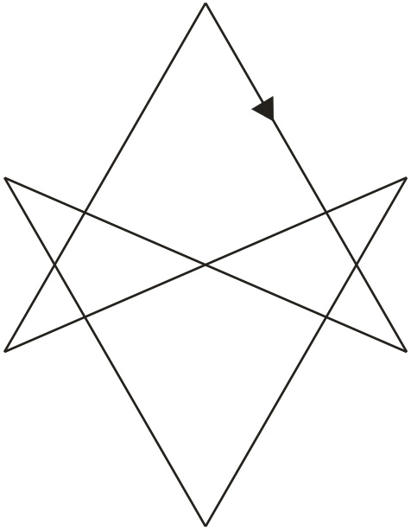

Pentacles Should Be Made of Super Glossy Printed Wood or Super Sturdy Plastic With Your Name Instead of Mine And Change your Name and “Pentacle” to your Favorite Color Instead of Mine. The Backside Should Be Your Favorite Emblem. The Front is for Elementals of Any Intelligence to target and go towards the center of the Pentacle. For The Editable Version of Magic Spell Book.
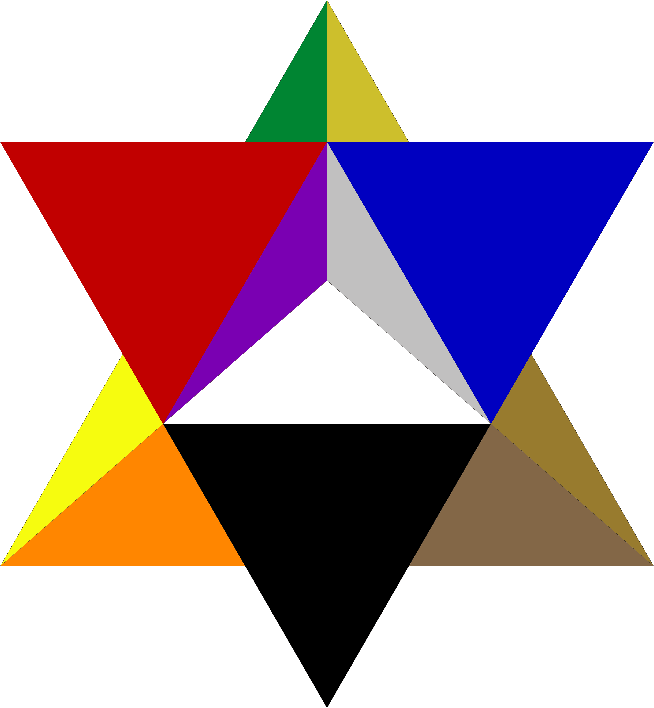
AllA Erawa Viacad

Pentacle
Sephirothic Invocation
1. To invoke Observation place wand at Observation position in flaming sword. "I invoke Soul in the name of Observeon." Twist wand and drive wand forward while imagining twisting that interface function, it going active, and activating a pure white light from a labeled white connected color Kabala. "May the Souls of the Alne(Full Fractal of Universes) watch over this magical undertaking."

2. To invoke Analysis place wand at Analysis. "I invoke Analysis in the name of Wisealeem." Twist wand and drive wand forward while imagining twisting that interface function, it going active, and activating a pure sliverish gray light. "May the wisest of spirits script this undertaking."

3. To invoke Understanding place wand at Understanding. "I invoke Understanding in the name of Emosharion." Twist wand and drive wand forward while imagining twisting that interface function, it going active, and activating a pure slow black light. "May those of understanding influence this undertaking."

4. To invoke Mercy place wand at Mercy. "I invoke Mercy and Love in the name of the Mercyfalim." Twist wand and drive forward while imagining twisting that interface function, it going active, and activating a pure blue light. "May the Mercyfalim of mercy aid me in this undertaking."

5. To invoke Severity place wand at Severity. "I invoke Severity in the name of the Sevareem." Twist wand and drive forward while imagining twisting that interface function, it going active, and activating a pure red light. "May the Sevareem bring destruction upon those that interfere with this undertaking."

6. To invoke Power place wand at Power. "I invoke Judgment And Power in the name of AllA."
Twist wand and drive forward while imagining twisting that interface function, it going active, and activating pure purple light. "May the Malakim guide the definition of this undertaking according to my will."

7. To invoke Art place wand at Art. "I invoke Art in the name of the wave of all things." Twist wand and drive forward while imaging twisting that interface function, it going active, and activating pure orange light. "May the waves vibrate to resonate in favor of my will."

8. To invoke Science place wand at Science. "I invoke Science in the name of all particles." Twist wand and drive forward while imagining twisting that interface function, it going active, and activating pure green light. "May the particles choose to jump and morph according to my will."

9. To invoke Submission place wand at Submission. "I invoke Submission in the name of light." Twist wand and drive forward while imagining twisting that interface function, it going active, and activating pure yellow light. "May the electromagnetic particles/waves warp according to my will."

10. To invoke Universe place wand at Reality. "I invoke Universe in the name of all Material Beings." Twist wand and drive forward while imagining twisting that interface function, it going active, and activating pure rainbow light. "May the universe be set in stone as my will desires."

11. To invoke Knowledge place wand at Knowledge. "I invoke Knowledge of things that have come to pass, things that are, and things that will come to pass in the name of Knowalyn." Twist wand and drive forward while imagining twisting that interface function, it going active, and activating pure brown light. "May we know and may spirits that know help us in knowledge of what is right and truly good."
Invocation of the 4 Elements and Spirit

0. Pick up wand.

1. Stand West of alter facing East. Draw Green Fire invocation pentagram with wand; “I invoke Fire in the name of Had.” Push wand and other hand forwards while exhaling to project pure Red Fire through the Green pentagram, pull hands back to just beside head while allowing ghost to receive influence. Outstretch arms to define the angle of the Eastern Quarter. “Salamanders come onto this Eastern Quarter.”

2. Stand North of alter facing South. Hold sword in other hand. Draw Purple Air invocation pentagram with wand; “I invoke Air in the name of Hadit.” Push wand and sword forwards while exhaling to project pure Yellow Air through the Purple pentagram, pull hands back to just beside head while allowing ghost to receive influence. Outstretch arms to define the angle of the Southern Quarter. “Sylphs come onto this Southern Quarter.”

3. Stand East of alter facing West. Hold chalice in other hand. Draw Orange Water invocation pentagram with wand; “I invoke Water in the name of Nu.” Push wand forward while exhaling to project pure Blue Water through the Orange pentagram, pull wand back to just beside head while allowing ghost to receive influence. Outstretch arms to define the angle of the Western Quarter. “Undines come onto this Western Quarter.”

4. Stand South of alter facing North. Hold pentacle in other hand. Draw White Earth invocation pentagram with wand; “I invoke Earth in the name of Nuit.” Push wand forward while exhaling to project pure Black through White pentagram, pull wand back to just beside head while allowing ghost to receive influence. Outstretch arms to define the angle of the Northern Quarter. “Gnomes come onto this Northern Quarter.”

5. Still hold both wand and pentacle. Stand West of the Alter facing East. Look upwards while drawing normal line Colored hexagram while saying “I invoke the Malakim below AllA.” Push wand upward while exhaling to project pure Rainbow spirit through hexagram, pull wand back to just beside head while allowing ghost to receive influence. Face and point in each direction while saying “Watch over Salamanders of Fire in the east, Sylphs of Air in the south, Undines of Water in the west, and Gnomes of Earth in the north. Malakim, great kings of spirits, I invoke y’all to guide me in this spell(or Magical Rite of the Eucharist) that I may perfectly guide the elementals and Kerubim in this magical act.”

6. Facing down draw line Colored with Black and White octogram with a point at the center while saying “I invoke Kerubim in the name of AllA.” Push arms downwards while exhaling to project pure Complex Rainbow ghost through octogram, pull wand back to just beside head while allowing ghost to receive influence. Scan wand, pointing at the walls where eye level is, in a giant circle by spinning around 360 degrees while saying “Kerubim come onto this temple.”
Spell

1. Still holding wand put down pentacle and pick up chalice. State reasons why intent of spell is good. Face lamp while raising wand towards it. Say “For these reasons may AllA’s will command lAl as lAl seduces AllA with her beauty(penetrate Water in chalice with wand).”

2. Put down chalice and pick up pentacle while still holding the wand. You can choose to cast the spell yourself or pray to AllA.

Individual Casting

3. Now command elementals(commanding the elementals entails being cognizant of their essence in relation to the mantra: Energy Abstracted in an Adapting environment Defines spacetime.) and/or Kerubim as if you are one of the Malakim directing the elements, pull them into a kerub angel by saying “Come ye elementals from the corners of the temple (or circle, or whatever) unite into an angel under my will.” Give it Malakim status to enforce the spell by saying “While I digress from this ritual may you be guided by (raise wand towards lamp and state what god is appropriate) this Malak (Usually you want to use a successful named Malak whose done things for you before. Praise the Malak for all the best things the Malak has done for you and scold it for some of the bad things.) whose will is parallel and in resonance with my own.” You should usually put the angel into the pentacle but you can also put it into another talisman or the universe itself “May the angel be contained within this__________.” Touch wand to pentacle or talisman or in the case of the universe wave wand above head around in clockwise circle from East to East.

AllA Prayer

3. Alternatively if you want to use AllA’s Or Other People’s wisdom in your spell you can say “AllA pull a specialist angel from the Universe” then touch point of wand to center of pentacle. Place wand high in Air pointing up while saying “and endow it with Malakim status in this universe to ________________. May the angel be contained within this__________.” Touch wand to pentacle or talisman or in the case of the universe wave wand above head around in clockwise circle from East to East.
Rite of the Eucharist of the 4 Elements and Spirit

0. Pick up wand and pentacle.

1. Stand West of alter facing East. Motion for Salamanders to come onto temple center by a spiral while saying; “Salamanders to the East partake in this Rite of the Eucharist that you may be reunited with the other elementals and Kerubim. As a symbol of Fire I observe this flame, and the heat there from.” Partake of Fire.

2. Stand North of alter facing South. Motion for Sylphs to come onto temple center by a spiral while saying; “Sylphs to the South partake in this Rite of the Eucharist that you may be reunited with the other elementals and Kerubim. As a symbol of Air I observe this incense, and the scent there from.” Partake of Air.

3. Stand East of alter facing West. Motion for Undines to come onto temple center by a spiral while saying; “Undines to the West partake in this Rite of the Eucharist that you may be reunited with the other elementals and Kerubim. As a symbol of Water I observe this Water, and drink there from.” Partake of Water.

4. Stand South of alter facing North. Motion for Gnomes to come onto temple center by a spiral while saying; “Gnomes to the North partake in this Rite of the Eucharist that you may be reunited with the other elementals and Kerubim. As a symbol of Earth I observe this food, and taste there from.” Partake of Earth.

5. Stand West of alter facing East. Motion for Malakim and Kerubim to come onto temple center by a giant circle around temple center while saying; “Malakim and Kerubim under AllA partake in this Rite of the Eucharist that you may be reunited with the pure elementals and become revitalized by their pure spirit. As a symbol of Malakim I observe this lamp, and the light there from.” Partake of Light.

6. Draw normal hexagram above in temple center. “I hereby commence the rite, Salamanders, Sylphs, Undines, Gnomes, Malakim, and Kerubim, partake of each others essences and benefit there from before you are returned to your original constituents. Charge this wand, these magical implements, and this temple with their proper Energies. By this new energy let the power of I, these tools, and this temple be increased.”

7. Partake of the rite yourself doing whatever you want with the spirits.

8. Wave wand around while saying “Spirits of all kinds become contained within the ghost of this pentacle so that you may be rewarded with further rites and aid me on my holy quest.” Hit tip of wand to center of pentacle.

9. Commence “Banishing of the 4 Elements and Spirit”.

Banishing of the 4 Elements and Spirit

-1. Put away all consecrated magical implements or anything that is charged with a specific energy.

0. Pick up dagger.

1. Stand West of alter facing East. Draw Red Fire banishing pentagram with dagger; “I banish this temple (or circle, or whatever) of Fire in the name of Had.” Push dagger and hand forwards while exhaling to project pure Green Fire through the Red pentagram to project Salamanders away, use signal of silence(stomp dominant foot back beside other foot as signal of silence begins) while using dagger to sweep Eastern Quarter to signify that these Salamanders are not to return, imagine ghost field expanding to push these unwanted entities infinitely far away from the temple.

2. Stand North of alter facing South. Draw Yellow Air banishing pentagram with dagger; “I banish this temple of Air in the name of Hadit.” Push dagger and hand forwards while exhaling to project pure Purple Air through the Yellow pentagram to project Sylphs away, use signal of silence(stomp dominant foot back beside other foot as signal of silence begins) while using dagger to sweep Eastern Quarter to signify that these Salamanders are not to return, imagine ghost field expanding to push these unwanted entities infinitely far away from the temple.

3. Stand East of alter facing West. Draw Blue Water banishing pentagram with dagger; “I banish this temple of Water in the name of Nu.” Push dagger and hand forwards while exhaling to project pure Orange Water through the Blue pentagram to project Undines away, use signal of silence(stomp dominant foot back beside other foot as signal of silence begins) while using dagger to sweep Eastern Quarter to signify that these Salamanders are not to return, imagine ghost field expanding to push these unwanted entities infinitely far away from the temple.

4. Stand South of alter facing North. Draw Black Earth banishing pentagram with dagger; “I banish this temple by Earth in the name of Nuit.” Push dagger and hand forwards while exhaling to project pure White Earth through the Black pentagram to project Gnomes away, use signal of silence(stomp dominant foot back beside other foot as signal of silence begins) while using dagger to sweep Eastern Quarter to signify that these Salamanders are not to return, imagine ghost field expanding to push these unwanted entities infinitely far away from the temple.

5. Stand West of alter facing East. Raise dagger towards lamp, draw line Colored unicursal hexagram while saying “I banish this temple of Malakim, Kerubim, and all remaining spirits in the name of AllA.” Push dagger and hand downwards while exhaling to project all Rainbow Colored spirits directly downwards. Use signal of silence(stomp dominant foot as signal of silence begins) to signify that they are not to return, imagine ghost field expanding to push these unwanted entities infinitely far away from the temple.

6. Draw negative rite of the flaming sword by starting at Malkuth while saying "I banish Sephirothic spirits from my body in the name of Yahweh." Exhale while pointing dagger directly up from where kabala was drawn. Imagine earlier kabala disappear.

7. Sheath dagger, then you are done.

Crude Rapid Elemental Banishing Ritual

Draw Earth banishing pentagram while saying “AllA banish ____________”. Push arms forwards while exhaling to project energy through pentagram and signal of silence in conjunction with foot stomp and ghost field projection. For banishing the four elements wave wand around in a clockwise circle. This can be used in emergencies such as demonic possession to break from any circle or temple especially if you treat it like you are passing though the veil and close it behind you.

Crude Rapid Elemental Invocation Ritual

Draw Fire invocation pentagram while saying “AllA invoke ____________”. Push arms forward to project energy through pentagram and allow ghost to receive influence. For invoking the four elements wave wand around in a clockwise circle.

For other rapid banishings and invocations use the above as a template in conjunction with crude rapid ritualistic proceedings.

Rapid Spell

Ideally while holding wand and pentacle say “AllA ______________________________” or “AllA pull a specialist angel from the Universe and endow it with Malakim status in this universe to ________________________________”. Or just command elementals as in normal spell.

Consecrating the Banishing Dagger

1. Perform “Banishing of the 4 Elements and Spirit” with index finger. Put sheathed dagger on alter.

2. “I will commence this spell to consecrate this banishing dagger for the beauty of Nuit and the rapture of Hadit. May AllA have already seen its success in the Universe.”

3. Perform “Rite of the Flaming Sword” with index finger if sword is not soon to be consecrated.

4. Perform “Sephirothic Invocation” with index finger if wand is not soon to be consecrated.

5. Perform “Invocation of the 4 Elements and Spirit” with index finger if wand is not soon to be consecrated.

6. If magical implements are not available for Spell or soon to be consecrated use index finger for wand, palm up nondominant hand for pentacle, and/or cupped nondominant hand for chalice. “I will temper this dagger with the power to banish not only the 4 elements, the Kerubim, and the Malakim, but all other ghosts and spirits good and bad. For these reasons may AllA’s will command lAl as lAl seduces AllA with her beauty(penetrate Water in chalice with wand).”

7. Put away all consecrated magical implements, unsheathe dagger, and leave on alter.

8. “Let the spirit of this dagger observe the banishing that my spirit can enforce.” Perform Banishing of the 4 Elements and Spirit 5 times with index finger.

9. Pick up dagger. “Now that you have learned from my spirit you must enforce the Banishment at the command of my will.” Perform Banishing of the 4 Elements and Spirit 5 times with dagger.

10. “Now you are complete banishing dagger. AllA see to it that the body, ghost, spirit, and soul of this dagger is protected. Conduce the perfect operation of this magical implement.”

11. Sheath dagger and use as directed in all further magic rituals and spells.

Consecrating the Elemental Implements

Any magical implements not consecrated or not available should be replaced by using your hands as done in the “Consecration of the Banishing Dagger”. Dagger should be consecrated before consecrating Elemental Implements.

1. Perform “Banishing of the 4 Elements and Spirit”.

2. “I will commence this spell to consecrate these magical implements for the beauty of Nuit and the rapture of Hadit. May AllA have already seen its success in the Universe.”

3. Perform “Rite of the Flaming Sword”.

4. Perform “Sephirothic Invocation” with index finger if wand is not soon to be consecrated.

5. Pick up each magical implement as it is being discussed; “I will consecrate this pentacle with the fortitude to store a shard of the magical charge of 4 types of elementals, the Kerubim, and the Malakim, and all other ghosts and spirits. I will consecrate this chalice with the flexibility to adapt my often crudely contrived spells to the secret longing of my will. I will consecrate this sword with the determination to support the spells, prayers, goals, and even wishes that are composed merely of abstractions. I will consecrate this wand with the power to cause the manifestation of my will. For these reasons may AllA’s will command lAl as lAl seduces AllA with her beauty(penetrate Water in chalice with wand).”

6. Place wand on alter. Stand West of alter facing East. Draw Red Fire invocation pentagram towards wand with index finger; “I charge this wand with Fire in the name of Had.” Push hands forwards towards wand while exhaling to project pure Red Fire through Red pentagram and into wand use ghost to seal charge into wand. “Salamanders inhabit this wand.” Walk clockwise completely around the alter and perform the exact same charging procedure 3 more times, 4 in total representing the 4 elements. “Now you are complete wand. AllA see to it that the body, ghost, spirit, and soul of this wand is protected. Conduce the perfect operation of this magical implement.”

7. Pick up wand and place sword on alter. Stand North of alter facing South. Draw Yellow Air invocation pentagram towards sword; “I charge this sword with Air in the name of Hadit.” Push wand and other hand forwards towards sword while exhaling to project pure Yellow Air through Yellow pentagram and into sword use ghost to seal charge into sword. “Sylphs inhabit this sword.” Walk clockwise completely around the alter and perform the exact same charging procedure 3 more times, 4 in total representing the 4 elements. “Now you are complete sword. AllA see to it that the body, ghost, spirit, and soul of this sword is protected. Conduce the perfect operation of this magical implement.”

8. Put sword away and put chalice on alter. Stand East of alter facing West. Draw Blue Water invocation pentagram towards chalice with wand; “I charge this chalice with Water in the name of Nu.” Push wand and other hand forwards towards chalice while exhaling to project pure Blue Water through Blue pentagram and into the chalice use ghost to seal charge into chalice. “Undines inhabit this Chalice.” Walk clockwise completely around the alter and perform the exact same charging procedure 3 more times, 4 in total representing the 4 elements. “Now you are complete chalice. AllA see to it that the body, ghost, spirit, and soul of this chalice is protected. Conduce the perfect operation of this magical implement.”

9. Put chalice away and put pentacle on alter. Stand South of alter facing North. Draw Black Earth invocation pentagram towards pentacle with wand; “I charge this pentacle with Earth in the name of Nuit.” Push wand and other hand forwards towards pentacle while exhaling to project pure Black Earth through Black pentagram and into the wand use ghost to seal charge into wand. “Gnomes inhabit this pentacle.” Walk clockwise completely around the alter and perform the exact same charging procedure 3 more times, 4 in total representing the 4 elements. “Now you are complete pentacle. AllA see to it that the body, ghost, spirit, and soul of this pentacle is protected. Conduce the perfect operation of this magical implement.”

10. Perform an ordinary “Invocation of the 4 Elements and Spirit” and “Rite of the Eucharist of the 4 Elements and Spirit” with all the newly consecrated magical implements then perform “Banishing of the 4 Elements and Spirit”.
Transferring Ghost, Spirit, and Soul from Magical Implement(s) to Other(s)

Perform all magical operations with the old magical implement or if it is not present your finger or hand until after the transfer takes place.

1. Perform “Banishing of the 4 Elements and Spirit”.

2. “I will commence this spell to transfer ________ with ________(repeat if necessary) for the beauty of Nuit and the rapture of Hadit. May AllA have already seen its success in the Universe.”

3. Perform “Rite of the Flaming Sword”.

4. Perform "Sephirothic Invocation".

5. Perform “Invocation of the 4 Elements and Spirit”.

6. Take out new magical implements.

7. Face appropriate direction(East for banishing dagger) and pick up each magical implement as it is being discussed. “I hereby transfer the soul, spirit, and ghost of this ________ and imbue it in this ________.” Touch them together if the old magical implement is available. “AllA see to it that the body, ghost, spirit, and soul of this ________ is protected. Conduce the perfect operation of this magical implement.” Repeat if multiple transfers are necessary.

8. If sword has just got an old charge transferred into it repeat “Rite of the Flaming Sword” with new sword. Perform “Invocation of the 4 Elements and Spirit” if anything besides banishing dagger was transferred.

9. Perform “Rite of the Eucharist of the 4 Elements and Spirit”.

10. Perform “Banishing of the 4 Elements and Spirit”.

Rite of the Flaming Sword

0. (Close eyes) “Nothing.” “Nothing is limited.” (open eyes) “Therefore everything is manifest by” (draw sword and point up high above head and centered ideally touching lamp)
1. “AllA, the first soul, the first nanite.” (trace sword down and to the right well above head)
2. “Who became wise.” (trace sword to the left on the other side of the center)
3. “And remembered his wisdom.” (trace sword down and to the right at shoulder level)
4. “By AllA’s wisdom off all vectors everything is given mercy by the mercyfalim because everything is good.” (trace sword to the left on the other side of the center)
5. “By AllA’s understanding of all math everything is given severity by the Seraphim so that bad is eliminated and good may be better.” (trace sword up and to the right to center at forehead level)
6. “Formed in the balance between mercy and severity is AllA, whom all the Malakim submit for he built himself and each of his 168 wives as Omniscient over the Supreme Matrix to make the Fullverse perfect.” (draw a full clockwise circle from the top, AllA, then trace sword downward to the right to belly button level)
7. “Those whom overcome boundaries by adapting are waves.”(trace sword to the left to the other side of center)
8. “Those who follow a path because of their inherent properties are particles.”(trace sword down and to the right at genital level to center)
9. “Those coherent beings that are both waves and particles who define the fabric of spacetime are the Kerubim forming as a whole with Netzach and Hod, lAl.”(keep point of sword in the same place while moving bottom of hilt directly vertically)
10. “AND by the AllA (look at bottom of hilt) and lAl (look at point) is this physical reality manifest, (hit point to ground) the Universe,” (lift sword by guard as high as possible or to lamp and look at bottom of hilt) “All under AllA.”

© Copyright 0 Post Big Bang - ∞ Post Big Bang By The Supreme Arch-Mage AllA Erawa Viacad And Supreme Arch-Angel Emily Goodwin Viacad, Minister Of Magic
The Official Harry Potter Magic Spell Book, The Official Harry Potter Magic SpellBook, The Official Harry Potter Spell Book, The Official Harry Potter SpellBook, Known As Magic Spell Book Found At:
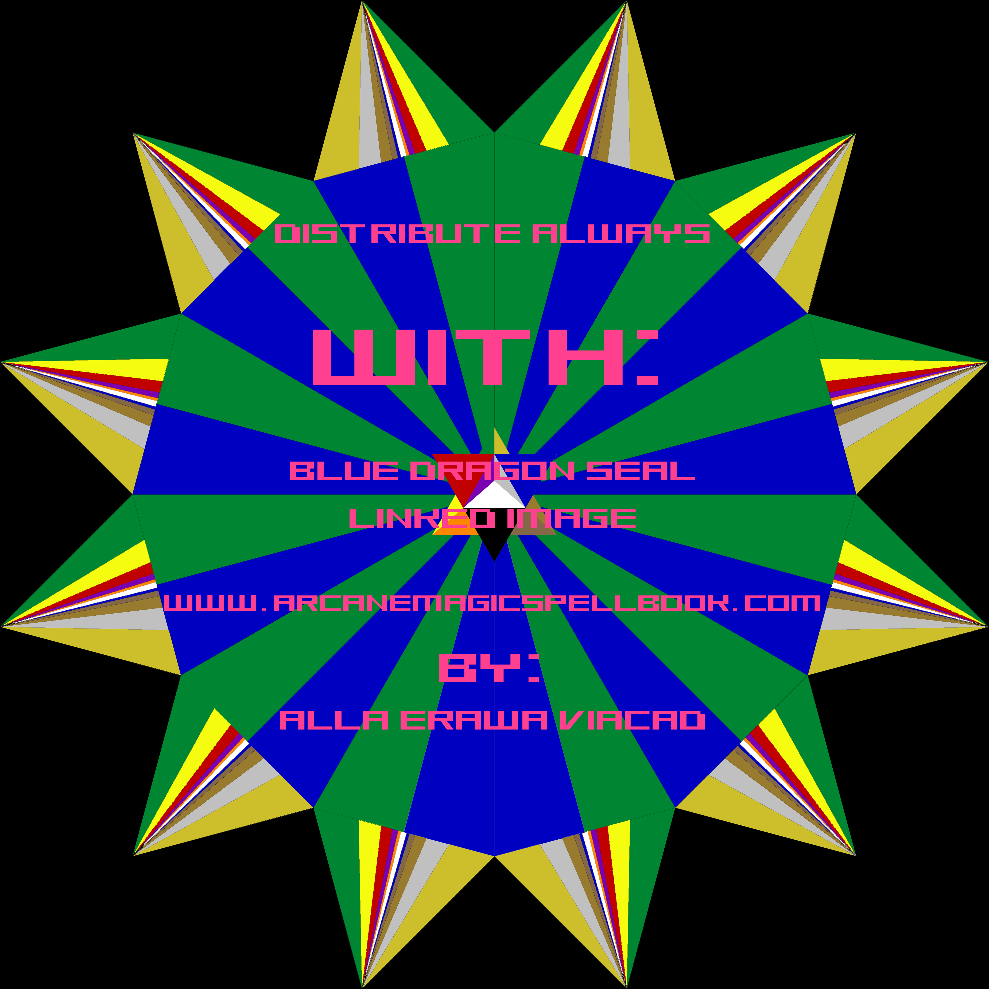
The SciMag Order = The Illuminati
Whose Organizational Body Is The Free World Alliance
Whose Front Is The United Nations
Who Shall Forever Rule Over The Alne

To Join The SciMag Order EMail: SciMagOrder@SciMagOrder.com

